Листинг кода:
Source.cpp
#include <windows.h>
#include <string.h>
#include <wchar.h>
#include <cstdio>
#pragma warning (disable:4996)
//LRESULT CALLBACK WndProc(HWND hwnd, UINT Message, WPARAM wParam, LPARAM lParam);
//void AddMenu(HWND);
//HINSTANCE g_hInst;
//#define PATH = "README.txt";
//
//int WINAPI WinMain(HINSTANCE hInstance, HINSTANCE hPrevInstance, LPSTR lpCmdLine, int nCmdShow)
//{
// HWND hwnd;
// MSG Msg;
// HICON hIcon;
// HCURSOR hCursor;
//
// TCHAR chClassName[] = TEXT("SIMPLEWND");
// WNDCLASSEX wcx;
// g_hInst = hInstance;
//
// hIcon = (HICON)LoadImage(0, IDI_APPLICATION, IMAGE_ICON, 0, 0, LR_SHARED);
// hCursor = (HCURSOR)LoadImage(0, IDC_ARROW, IMAGE_CURSOR, 0, 0, LR_SHARED);
// wcx.cbSize = sizeof(WNDCLASSEX);
// wcx.style = CS_HREDRAW | CS_VREDRAW;
// wcx.lpfnWndProc = (WNDPROC)WndProc;
// wcx.cbClsExtra = 0;
// wcx.cbWndExtra = 0;
// wcx.hInstance = hInstance;
// wcx.hIcon = hIcon;
// wcx.hCursor = hCursor;
// wcx.hbrBackground = (HBRUSH)(COLOR_BTNFACE + 1);
// wcx.lpszMenuName = NULL;
// wcx.lpszClassName = chClassName;
// wcx.hIconSm = NULL;
//
// RegisterClassEx(&wcx);
//
// hwnd = CreateWindowEx(0,
// chClassName,
// TEXT("Редактор"),
// WS_OVERLAPPEDWINDOW,
// GetSystemMetrics(SM_CXSCREEN) / 4,
// GetSystemMetrics(SM_CYSCREEN) / 4,
// GetSystemMetrics(SM_CXSCREEN) / 2,
// GetSystemMetrics(SM_CYSCREEN) / 2,
// NULL,
// NULL,
// hInstance,
// NULL);
//
// HANDLE hFile = CreateFile(L"README.txt",
// GENERIC_READ | GENERIC_WRITE,
// FILE_SHARE_READ,
// NULL,
// OPEN_ALWAYS,
// FILE_ATTRIBUTE_NORMAL,
// NULL);
// DWORD dwByteRead;
//
// BOOL flag;
//
// int buffer[4096];
//
// ReadFile(hFile, &buffer, sizeof(buffer), &dwByteRead, NULL);
//
//
//
// CloseHandle(hFile);
// ShowWindow(hwnd, nCmdShow);
// UpdateWindow(hwnd);
//
// while (GetMessage(&Msg, NULL, 0, 0) > 0)
// {
// TranslateMessage(&Msg);
// DispatchMessage(&Msg);
// }
// return Msg.wParam;
//}
//
//LRESULT CALLBACK WndProc(HWND hwnd, UINT Message, WPARAM wParam, LPARAM lParam)
//{
// RECT rct;
// switch (Message)
// {
// //case WM_COMMAND:
// // switch (wParam)
// // {
// // case
// // }
// // ;
// case WM_CREATE:
// AddMenu(hwnd);
// GetClientRect(hwnd, &rct);
// CreateWindowEx(/*WS_EX_CLIENTEDGE*/WS_EX_ACCEPTFILES,
// TEXT("EDIT"),
// TEXT("Текстовый редактор"),
// WS_CHILD | WS_VISIBLE | WS_BORDER |
// ES_MULTILINE,
// 10,
// 10,
// rct.right - 20,
// rct.bottom - 20,
// hwnd,
// NULL,
// g_hInst,
// NULL);
// return 0;
//
// case WM_DESTROY:
// PostQuitMessage(0);
// return 0;
// default:
// return DefWindowProc(hwnd, Message, wParam, lParam);
// }
//}
//void AddMenu(HWND hwnd)
//{
// HMENU hMenuBar;
// HMENU hMenu;
//
// hMenu = CreateMenu();
// hMenuBar = CreateMenu();
//
// AppendMenuW(hMenu, MF_STRING, NULL, L"Create");
// AppendMenuW(hMenu, NULL, NULL, NULL);
// AppendMenuW(hMenu, MF_STRING, NULL, L"Open");
// AppendMenuW(hMenu, NULL, NULL, NULL);
// AppendMenuW(hMenu, MF_STRING, NULL, L"Save");
// AppendMenuW(hMenu, MF_STRING, NULL, L"Save as");
//
// AppendMenuW(hMenuBar, MF_POPUP, (UINT_PTR)hMenu, L"&File");
//
// SetMenu(hwnd, hMenuBar);
//
//}

#include "Header.h"

LRESULT CALLBACK MainWindowProc(HWND hWnd, UINT msg, WPARAM wp, LPARAM lp);

HWND hEdit;

int WINAPI WinMain(HINSTANCE hInst, HINSTANCE hPrevInst, LPSTR args, int ncmdshow) {
HINSTANCE g_hInst = hInst;
WNDCLASSW wc = { 0 };
wc.hbrBackground = (HBRUSH)COLOR_WINDOW;
wc.hCursor = LoadCursor(NULL, IDC_ARROW);
wc.hInstance = hInst;
wc.lpszClassName = L"MainWndClass";
wc.lpfnWndProc = MainWindowProc;

if (!RegisterClassW(&wc))
return -1;

CreateWindowW(
L"MainWndClass", L"Notepad",
WS_OVERLAPPEDWINDOW | WS_VISIBLE,
400, 200, 500, 250,
NULL, NULL, NULL, NULL
);

MSG msg = { 0 };
while (GetMessage(&msg, NULL, NULL, NULL)) {
TranslateMessage(&msg);
DispatchMessage(&msg);
}
return 0;
}

void Editor(HWND hWnd)
{
hEdit = CreateWindowW(L"Edit", L"Text", WS_VISIBLE | WS_CHILD | ES_MULTILINE | WS_BORDER | WS_VSCROLL | WS_HSCROLL,
10, 50, 400, 300, hWnd, NULL, NULL, NULL, NULL);
}

void Menubar(HWND hWnd) {
HMENU MainMenu = CreateMenu();
HMENU FileMenu = CreateMenu();
HMENU EditMenu = CreateMenu();

AppendMenu(MainMenu, MF_POPUP, (UINT_PTR)FileMenu, L"File");
AppendMenu(FileMenu, MF_STRING, MB_NEW, L"New");
AppendMenu(FileMenu, MF_STRING, MB_OPEN, L"Open");
AppendMenu(FileMenu, MF_SEPARATOR, NULL, NULL);
AppendMenu(FileMenu, MF_STRING, MB_SAVE, L"Save");
AppendMenu(FileMenu, MF_STRING, MB_SAVEAS, L"Save as");
AppendMenu(FileMenu, MF_SEPARATOR, NULL, NULL);
AppendMenu(FileMenu, MF_STRING, MB_CLOSE, L"Close");
AppendMenu(FileMenu, MF_SEPARATOR, NULL, NULL);
AppendMenu(FileMenu, MF_STRING, MB_EXIT, L"Exit");

AppendMenu(MainMenu, MF_POPUP, (UINT_PTR)EditMenu, L"Edit");
AppendMenu(EditMenu, MF_STRING, MB_CUT, L"Cut");
AppendMenu(EditMenu, MF_STRING, MB_COPY, L"Copy");
AppendMenu(EditMenu, MF_STRING, MB_PASTE, L"Paste");
AppendMenu(EditMenu, MF_SEPARATOR, NULL, NULL);
AppendMenu(EditMenu, MF_STRING, MB_SELALL, L"Select all");

SetMenu(hWnd, MainMenu);
}

void DisplayFile(char* path)
{

FILE* file = new FILE();
file = fopen(path, "rb");
fseek(file, 0, SEEK_END);
int _size = ftell(file);
rewind(file);
char* data = new char[_size + 1];
fread(data, _size, 1, file);
data[_size] = '\0';
size_t size = strlen(data) + 1;
LPWSTR huy = new WCHAR[size];
mbstowcs(huy,data,size);
SetWindowText(hEdit, huy);
}

void OpenFile(HWND hWnd)
{
OPENFILENAME ofn;

char file_name[100];

ZeroMemory(&ofn, sizeof(OPENFILENAME));

ofn.lStructSize = sizeof(OPENFILENAME);
ofn.hwndOwner = hWnd;
ofn.lpstrFile = (LPWSTR)file_name;
ofn.lpstrFile[0] = '\0';
ofn.nMaxFile = 100;
ofn.lpstrFilter = L"ALL files\0*.*\0Source Files\0*.CPP\0Text Files\00*.TXT\0";
ofn.nFilterIndex = 1;

GetOpenFileName(&ofn);

DisplayFile((char*)ofn.lpstrFile);
}
LRESULT CALLBACK MainWindowProc(HWND hWnd, UINT msg, WPARAM wp, LPARAM lp) {
RECT rct;
switch (msg)
{
case WM_CREATE: {
Menubar(hWnd);
Editor(hWnd);
break;
}
case WM_COMMAND: {
switch (wp) {
case MB_OPEN: {
OpenFile(hWnd);
break;
}
case MB_CUT: {
SendMessage(hEdit, WM_CUT, 0, 0);
break;
}
case MB_PASTE: {
SendMessage(hEdit, WM_PASTE, 0, 0);
break;
}
case MB_COPY: {
SendMessage(hEdit, WM_COPY, 0, 0);
break;
}
case MB_SELALL: {
SendMessage(hEdit, EM_SETSEL, 0, -1);
break;
}
}
break;
}
case WM_CLOSE: {
PostQuitMessage(0);
break;
}
case WM_SIZE: {
MoveWindow(hEdit, 0, 0, LOWORD(lp), HIWORD(lp), FALSE);
break;
}

}
return DefWindowProcW(hWnd, msg, wp, lp);
}

Header.h
#pragma once
#define MB_NEW 100
#define MB_OPEN 101
#define MB_SAVE 102
#define MB_SAVEAS 103
#define MB_CLOSE 104
#define MB_EXIT 105

#define MB_UNDO 110
#define MB_REDO 111
#define MB_CUT 112
#define MB_COPY 113
#define MB_PASTE 114
#define MB_SELALL 115

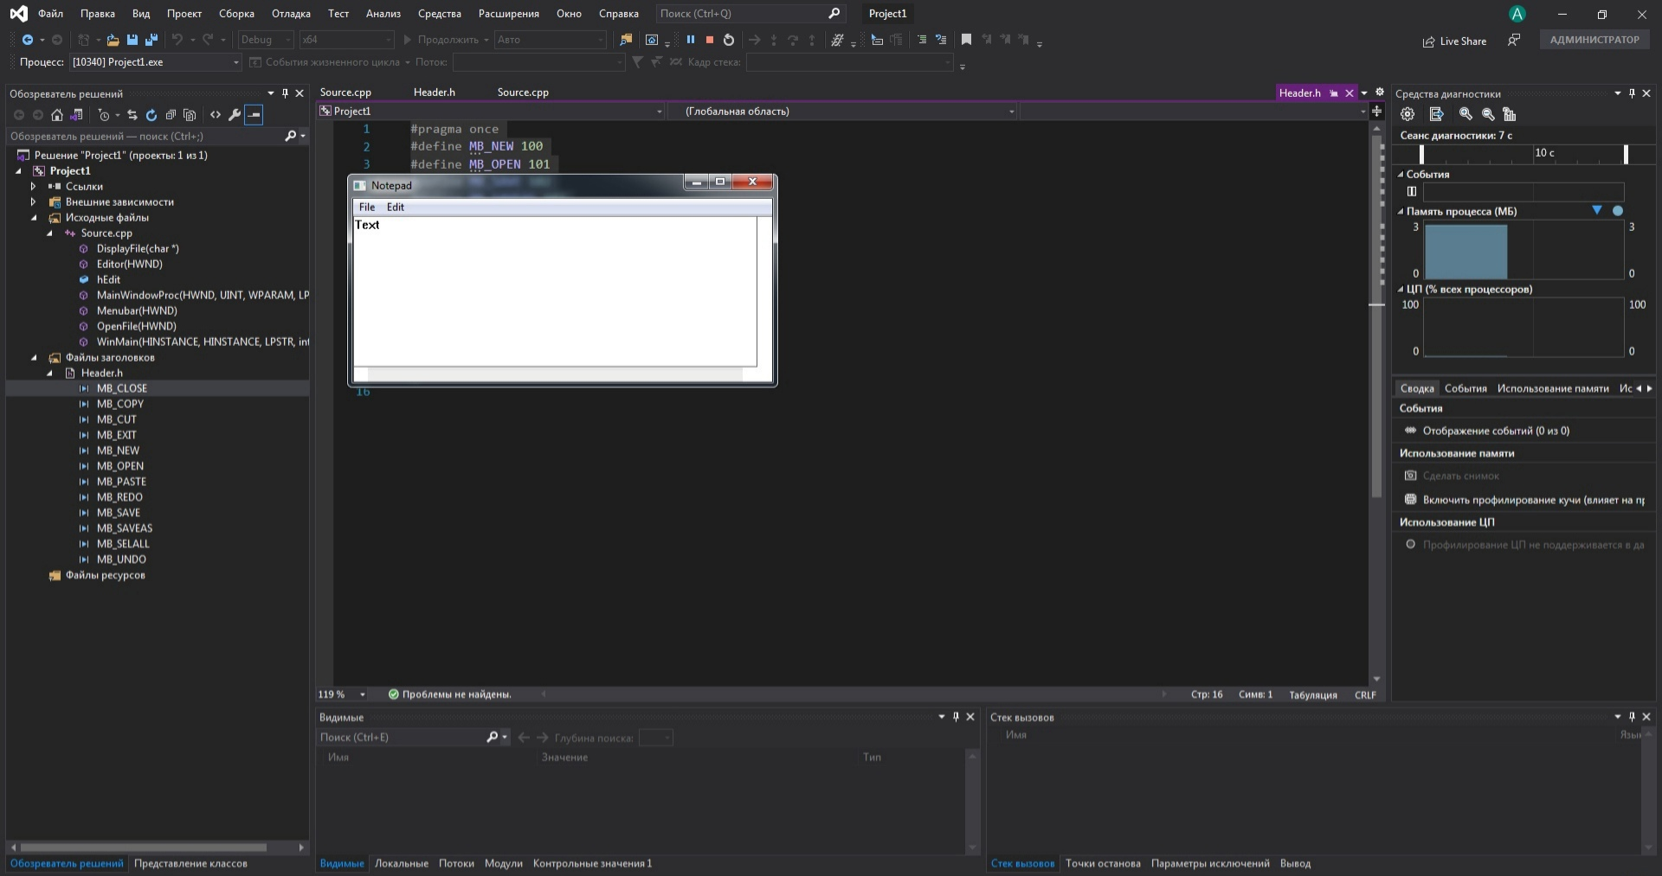
Скриншот

